

Federal Democratic Republic of Ethiopia
Ministry of Water and Energy
Ethiopia Flood Management Project

Terms of References (ToRs)
For Consultancy Services for the Construction Supervision and Contract Administration of the Different Structural Works in Rift Valley & Awash Basins (in two lots)
- Consultancy Services for the Supervision and Contract Administration of Crossing Structures and Related Infrastructure under the Middle and Lower Awash Flood Protection Projects (Lot 1)

- Consultancy Services for Supervision and Contract Administration of Crossing Structures and Related Infrastructure under the Upper Awash & Rift Valley Flood Protection Projects (Lot 2)

March 2026
Addis Ababa, Ethiopia

Federal Democratic Republic of Ethiopia
Ministry of Water and Energy
Ethiopia Flood Management Project

Terms of Reference (TOR)

Consultancy Services for Supervision and Contract Administration of Crossing Structures and Related Infrastructure in the Middle and Lower Awash Flood Protection Projects
(Lot 1)

March, 2026
Addis Ababa
Ethiopia

Contents
1. Introduction 2
2. Background 5
3. Location 5
4. Objectives of the Assignment 6
5. Scope of Services 8
5.1 Pre-Construction Phase 9
5.2 Construction Supervision and Quality Control 10
5.3 Measurement of Works and Payment Certification 10
5.4 Contract Administration and Technical Support 11
5.5 Training and Capacity Building for Operation and Maintenance 11
5.6. Environmental, Social, and OHS Compliance 12
5.7. Coordination and Stakeholder Engagement 12
5.8. Reporting and Documentation 12
5.9. Defects Liability Period and Completion 13
6. Staffing Requirements 14
7. Deliverables & Payment Terms 17
8. PAYMENT TERMS 18
9. Duration 19
10. Ethics, Quantity Measurement, Quality Control, and Payment Approval Responsibilities 20

List of Table
Table 6. 1: Staff Qualification and Experience 7
Table 7. 1: Report Deliverables and timelines 8

- Introduction
This Terms of Reference (ToR) relates to the provision of Construction Supervision and Contract Administration Services for the construction of crossing structures and related water access infrastructure under the Ethiopian Flood Management Project (EFMP) in the Awash Basin.
The assignment is specifically focused on the supervision of pedestrian steel bridges (river crossing structures), irrigation water intake systems, and cattle watering facilities, turnout/off-take rehabilitation works, and solar-powered pumping systems to be implemented in selected locations within the Middle and Lower Awash sub-basins.
The Awash Basin, particularly in flood-prone areas such as Gewane, Gelalo, Haruka, Asayeta, and Afambo, has previously benefited from flood protection works implemented to reduce river overflow risks and protect communities, farmland, and infrastructure. While these interventions have improved flood safety, critical gaps remain in safe river crossing, controlled water abstraction, livestock watering facilities, and small-scale irrigation access.
During high-flow seasons, the absence of properly designed crossing structures limits mobility of communities, livestock, and goods, disrupting socio-economic activities and access to services. Similarly, the lack of engineered intake structures and controlled irrigation outlets reduces the effectiveness and sustainability of existing flood protection investments. In several locations, informal water abstraction practices and inadequate livestock watering points also pose risks to riverbanks and previously constructed flood protection structures.
To address these site-specific challenges, the EFMP has initiated additional complementary works that integrate mobility, water access, and resilience objectives with the existing flood protection infrastructure. These works include:
- Steel pedestrian bridges to ensure safe and all-season river crossing;
- Intake for irrigation;
- cattle watering facilities;
- Solar-powered pumping systems and associated electro-mechanical components.
These interventions are designed to strengthen the functional performance of prior flood protection works, reduce riverbank disturbance, improve community safety, enhance climate resilience, and maximize socio-economic benefits.
This ToR defines the scope and requirements for the Consultant responsible for supervising and administering the construction contracts for these crossing structures and related infrastructure. The supervision services shall ensure that all works are executed in full compliance with approved designs, technical specifications, Bills of Quantities (BoQs), Environmental and Social Management instruments, and the applicable World Bank procurement and contract management requirements, while addressing the hydrological, geotechnical, and logistical conditions specific to the Middle and Lower Awash areas.
The assignment therefore directly contributes to the sustainable performance of flood protection investments by ensuring that complementary crossing and water access infrastructure is constructed safely, efficiently, and to the required quality standards.

- Background
The Awash Basin is one of Ethiopia’s most economically and socially significant basins, supporting agriculture, livestock, industry, and urban settlements. Over the years, recurrent flooding has caused substantial damage to farmland, infrastructure, and community assets. To address these challenges, flood protection structures were previously constructed in the basin, which have played a crucial role in reducing flood risks and safeguarding livelihoods.
However, despite these interventions, local communities have continued to raise concerns regarding their day-to-day needs. Key issues include the lack of adequate water intake systems for irrigation, insufficient facilities for livestock watering, and the absence of safe pedestrian crossings in flood-affected areas. These gaps limit the effectiveness of the existing flood protection works and hinder the full socio-economic benefits expected from the earlier investments.
In response, the current project has been initiated to construct an intake structure, a footbridge, and a cattle trough within the Awash Basin. These additional works are designed to complement the existing flood protection measures, address community demands, and enhance the long-term resilience and sustainability of the basin’s resources
- Location
The project is located within the Awash Basin (Middle & Lower Awash), one of Ethiopia’s most significant river basins that extend across multiple regions. The basin plays a central role in supporting agriculture, livestock, settlement, and industrial activities, making it highly important for both local and national development.
The proposed interventions are: Construction of intakes, footbridges, and a cattle trough—will be implemented in selected sites where flood protection works were previously implemented, and where additional facilities are required to meet community demands and sustainability of sub-projects. The project sites are situated in two principal sub-basins and are being implemented under two separate civil works contract lots:
- Middle Awash: Gewane, Gelalo, and Haruka
- Lower Awash: Asayeta and Afambo
These locations were selected following a critical assessment of mobility and water access challenges and the need to maximize the effectiveness of existing flood protection projects. By focusing on these areas, the project aims to improve water access, enhance safe mobility and connectivity, and reinforce resilient livelihoods.
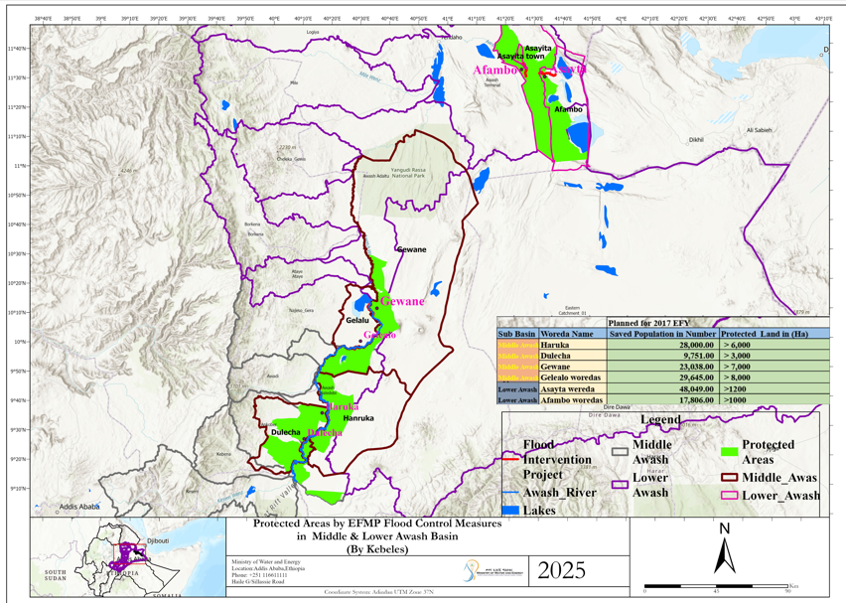
Figure 1. Location Map of Middle and Lower Awash Flood Protection Projects.
- Objectives of the Assignment
The overall objective of this assignment is to provide comprehensive construction supervision and contract administration services for the structural works to be implemented under the Ethiopian Flood Management Project in the Awash Basin, including pedestrian bridges, water intake structures, cattle troughs, and associated civil works.
The supervision services aim to ensure that all construction activities are carried out in full compliance with the approved designs, technical specifications, Bills of Quantities, Environmental and Social Management instruments, and World Bank procurement and contract management requirements, within the agreed time, cost, and quality standards.
Specifically, the objectives of the supervision assignment are to:
- Ensure that the construction works are executed in accordance with the approved engineering designs, drawings, specifications, and applicable Ethiopian and international standards;
- Monitor, control, and document construction quality, progress, quantities, and site safety, and verify that materials, workmanship, and construction methods meet the required standards;
- Measure and quantify executed works, maintain accurate site records, and review, certify, and recommend contractors’ interim and final payment requests in accordance with the contract provisions;
- Prepare and submit regular progress reports (monthly, quarterly, and as required) to the Ethiopian Flood Management Project (EFMP), covering physical progress, financial status, quality control, environmental and social compliance, key issues, and risk mitigation measures;
- Ensure full compliance with environmental, social, occupational health and safety (OHS), and community protection requirements, including the implementation of mitigation measures outlined in the ESMP;
- Provide effective contract administration services, including review of contractors’ work programs, method statements, shop drawings, and management of variations, claims, and extensions of time;
- Identify, assess, and resolve technical and implementation challenges in a timely manner, and recommend corrective actions or design adjustments where necessary, in consultation with the Client;
- Coordinate and integrate implementation activities with relevant local administrations, sector offices, and beneficiary communities, to facilitate smooth construction progress, minimize disruptions, and address community concerns;
- Ensure that the completed structures are safe, functional, climate-resilient, and responsive to local needs, thereby maximizing the socio-economic and flood risk reduction benefits of the investments.
The assignment ultimately seeks to support the successful, timely, and sustainable delivery of flood-resilient infrastructure, contributing to improved community mobility, water access, and livelihood protection in the Awash Basin.
- Scope of Services
The Consultant shall provide full-time construction supervision and contract administration services for the structural works to be implemented under the Ethiopian Flood Management Project in the Awash Basin. The scope of services shall cover the entire construction period, including defects liability, and shall include but not be limited to the following tasks:

Middle Awash (Lot 1)
Lot | Location | Irrigation Pipe Supply and Installation with Valve Chamber Construction | Steel Bridge
1 | Haruka & Dulecha | 4 | 4
 | Gewane | 13 | 3
 | Gelalo | — | 2
Total |  | 17 | 9

Lower Awash (Lot 2 – Asayita and Afambo)
Lot | Location | Irrigation Pipe Supply and Installation with Valve Chamber Construction | Cattle Trough, Pipe Supply and Installation with Valve Chamber Construction | Turn Out / Off-Take Maintenance / Rehabilitation | Steel Footbridge (River Crossing)
2 | Asayita | 38 | 5 | 22 | 4
 | Afambo | 38 | 5 | 22 | 4
Total |  | 76 | 10 | 44 | 8

Electromechanical Equipment’s.
Item No. | Description | No of Structure
Item No. | Description | (in PCS)
1 | Solar Panel with Submersible Pump
 | SUB TOTAL
The above projects will be revised based on the final designs submitted by the design consultant, and the locations and capacities of the solar panels, along with the pumps and their locations, will be determined following the completion of the final design

5.1 Pre-Construction Phase
- Review and familiarize with all relevant project documents, including detailed engineering designs, drawings, technical specifications, Bills of Quantities (BoQs), Environmental and Social Management Plans (ESMPs), and contract documents;
- Assist the Client during the mobilization and commencement phase, including participation in site handover and pre-construction meetings;
- Review and approve the Contractor’s:
  - Work program and construction schedule,
  - Method statements,
  - Site layout plans,
  - Quality assurance and quality control (QA/QC) plans,
  - Environmental, social, and occupational health and safety (OHS) implementation plans;
- Verify availability and suitability of construction materials, equipment, personnel, and laboratories prior to commencement of works.

5.2 Construction Supervision and Quality Control
- Provide continuous on-site supervision to ensure that construction works for pedestrian bridges, water intake structures, cattle troughs, and associated civil works are executed in accordance with:
  - Approved designs and drawings,
  - Technical specifications and BoQs,
  - Applicable Ethiopian standards and relevant international best practices;
- Monitor construction progress against the approved schedule and identify potential delays, bottlenecks, and risks;
- Ensure proper setting-out, alignment, levels, dimensions, and structural integrity of all works;
- Supervise material testing, workmanship, and construction methods to ensure compliance with quality standards;
- Ensure that construction activities are implemented in a climate-resilient and technically sound manner, suitable for flood-prone environments.

5.3 Measurement of Works and Payment Certification
- Measure, verify, and quantify executed works on a regular basis in accordance with the BoQs and contract provisions;
- Maintain accurate site records, including daily logs, measurement books, test results, and photographic documentation;
- Review, certify, and recommend:
  - Interim Payment Certificates (IPCs),
  - Final payment certificates,
ensuring that payments correspond to actual completed and approved works;
- Verify variations and provisional sums and provide technical justification and recommendations to the Client.

5.4 Contract Administration and Technical Support
- Administer the construction contract in accordance with the applicable World Bank Standard Procurement Documents and Conditions of Contract;
- Review and approve shop drawings, as-built drawings, and construction details submitted by the Contractor;
- Assess and make recommendations on:
  - Variations,
  - Claims,
  - Extensions of time,
  - Price adjustments, where applicable;
- Identify design or site-related issues encountered during construction and propose practical technical solutions in consultation with the Client;
- Ensure timely completion of works within the approved budget and contractual timeframe.

5.5 Training and Capacity Building for Operation and Maintenance
- Plan and conduct practical, community-level training on the operation and maintenance (O&M) of solar-powered pumping irrigation systems installed under the Project;
- Develop simple and user-friendly training materials (manuals, checklists, and visual aids) in a language understandable to the local community;
- Train selected community members, water user groups, and relevant local stakeholders on:
- Basic system components and functions of solar pumping systems,
a. Routine operation procedures and safety practices,
b. Preventive maintenance and troubleshooting,
c. Efficient water use and system protection during flood and dry seasons;
- Demonstrate hands-on operation of the systems at site level to ensure practical understanding and sustainability;
- Support the establishment or strengthening of community-based O&M arrangements to ensure long-term functionality of the irrigation systems;
- Document training activities, attendance, and outcomes, and submit training completion reports to the Client

5.6. Environmental, Social, and OHS Compliance
- Supervise and monitor implementation of all environmental, social, and occupational health and safety (OHS) measures as outlined in the ESMP and contract documents;
- Ensure protection of workers, communities, livestock, and existing infrastructure during construction;
- Monitor community health and safety risks, including safe access, pedestrian movement, and livestock crossings;
- Report and follow up on any incidents, non-compliance issues, or grievances, and ensure corrective actions are implemented promptly.

5.7. Coordination and Stakeholder Engagement
- Coordinate construction activities with:
  - Local administrations,
  - Relevant sector offices,
  - Basin Development Offices,
  - Beneficiary communities;
- Facilitate effective communication between the Contractor, the Client, and local stakeholders to minimize disruptions and address community concerns;
- Support conflict resolution related to access, land use, water use, and construction impacts during implementation.

5.8. Reporting and Documentation
- Prepare and submit regular progress reports to the Ethiopian Flood Management Project (EFMP), including:
  - Weekly report
  - Bi-weekly take-off sheets, signed by both parties, for earth work accompanied by supporting documents such as survey data (Original Ground Level vs. As-Built data)
  - Monthly progress reports,
  - Quarterly summary reports,
  - Special reports as required;
- Reports shall cover physical progress, financial status, quality assurance, environmental and social compliance, key challenges, and recommended actions;
- Prepare completion reports, including as-built documentation and final technical summaries at the end of the assignment.

5.9. Defects Liability Period and Completion
- Supervise works during the Defects Liability Period, including inspection of reported defects and verification of corrective actions;
- Verify completion of outstanding works and certify issuance of completion and defects liability certificates;
- Support the Client during final handover of the completed structures.

- Staffing Requirements
Table 6.1: Key Staff Qualification, Experience, and Input
No. | Position | No. of Staff | Minimum Qualification | Relevant Experience | Input / Duration (Months)
1 | Resident Engineer (Team Leader & Contract Specialist) | 1 | MSc/BSC in Civil / Hydraulic / Water Resources Engineering,or related field | Minimum 10/12 years of professional experience in flood protection, river engineering, or related infrastructure projects, including at least 4 years in construction supervision and strong experience with World Bank Projects | 10
2 | Site Engineer | 2 | MSc/BSc in Civil Engineering/Hydraulic Engineering ,or related field | Minimum 6/8 years of experience in supervision of civil works including bridges, intake structures and hydraulic structures, and flood. | 10
3 | Geotechnical & Materials Engineer | 1 | MSc/Bsc in Geotechnical Engineering / Engineering Geology or, related field | Minimum 6/8 years of experience in soil investigations, foundation design review, embankments, material testing, and QA/QC for hydraulic and flood-related infrastructure | 9
4 | Quantity Surveyor | 1 | MSc/Bsc in Civil Engineering/Hydraulic Engineering ,or related field | Minimum 6/8 years of professional experience in quantity surveying and cost management of civil works projects, including preparation and review of Bills of Quantities (BoQ), cost estimation, contract administration, measurement and valuation of works, and related | 9
5 | Structural Engineer | 1 | MSc/Bsc in Civil/Structural Engineering ,or related field | Minimum 6/8 years of experience in design review and supervision of reinforced concrete and steel structures, including pedestrian bridges and hydraulic structures.  And a minimum of three (3) years of proven experience in steel bridge design and/or construction supervision. | 9
6 | Electro-Mechanical Engineer | 1 | BSc or MSc in Electro-Mechanical / Electrical / Mechanical Engineering | Minimum 6/8 years of experience in installation, testing, commissioning, and supervision of solar-powered pumping systems, electro-mechanical equipment, and irrigation infrastructure | 4
7 | Environmental & Social Specialist | 1 | MSc/Bsc in Environmental Science, Social Works, or related field | Minimum 8/6 years of experience in World Bank environmental and social safeguards, ESMP implementation, OHS, and community engagement | 9
8 | Surveyor & CAD Technician | 2 | BSc/Diploma in Surveying or related field | Minimum 6/8 years of experience in topographic surveys, setting-out of civil works, quantity verification, and preparation of as-built drawings | 9

Note:- The supervision arrangement shall comprise two field teams, each consisting of a Site Engineer and a Surveyor. These teams shall be supported by key professional staff, including a Resident Engineer, Geotechnical Engineer, Quantity Surveyor, Structural Engineer, Electro-Mechanical Engineer, and Environmental and Social Specialist and the consultant deploy its staff in full time based.
All assigned key personnel are full-time staff dedicated to the project in accordance with the man-month inputs specified in the ToR.

Table 6.2. Vehicles, Field Testing Equipment, and Field Office Facilities Provided by the Consultant
No. | Description | Purpose | Quantity | Duration  (Month) | Remarks
1 | 4WD Vehicle | For site supervision, coordination, and field mobility in flood-prone areas specifically for Team Leader | 1 | 10 | Fully equipped with fuel, driver, insurance, and maintenance
2 | 4WD Vehicles | For parallel site supervision and technical staff mobility | 2 | 9 | Same conditions as above
3 | Total Station | Surveying, setting-out, level control, quantity verification, and as-built surveys | 1 | 9 | Complete with accessories
4 | Dynamic Cone Penetrometer (DCP) &  Concrete Slump Test Apparatus (Abrams Cone) | Field tests and basic QA/QC support for construction supervision | 1 | 9 | Supporting Site and Geotechnical Engineers through field soil strength testing (DCP) and concrete workability testing (slump test) during supervision
5 | Field Office Rent | Provision of fully equipped field office for the supervision team, including office furniture, , and space for reporting and coordination activities. | 2 | 9 | For coordination activities
Note: The vehicles and other materials required for the project shall be used by the Consultant exclusively for project implementation. The Consultant is required to quote monthly service rental rates for these resources in the financial proposal.
Upon completion of the assignment, all vehicles and materials shall remain the sole property of the Consultant, and no ownership shall be transferred to the Client.

Table 6.3. Reporting and Documentation
No | Description | Unit | Qty | Remarks
1. | Preparation of Monthly Progress report together with 4 Weeks status report and 2 Biweekly report together with all supporting documents | Monthly. | 9 | Includes drafting, compilation, printing, and submission to Client
2. | Completion Report and as built Drawing | No. | 1 | Includes drafting, compilation, printing, and submission to Client
- Deliverables & Payment Terms
Table 7. 1: Report Deliverables and timelines
Deliverable | Submission Timeline
Inception Report | 2 weeks
Weekly Status Report | weekly
Bi weekly Takeoff sheet signed by both parties for earth work supported by Surveying Data | Bi-Weekly
Monthly Progress Reports | Monthly
Safeguard Compliance Reports | Quarterly
Environmental & Social Compliance Audit | Quarterly
Final Completion Report | Post-construction
As-built Drawings & operation and maintenance manual | Post-construction
Final Payment Certificate | End of project

- PAYMENT TERMS
The Consultant’s remuneration shall be structured based on the delivery of services and submission of required outputs, as follows:
Advance Payment.
Upon provision of an unconditional Advance Payment Guarantee, the Client will pay an advance of 10% of the Contract Amount. The advance shall be repaid in installments deducted from each interim payment, with the full amount to be recovered by the time the cumulative financial progress of the Works reaches 80% of the Contract Amount
- Interim Payments:
  - Interim payments shall be made on a monthly basis, subject to the submission and approval of the Consultant’s progress reports, bi-weekly quantity takeoff sheets supported by verified surveying data, and confirmation of satisfactorily executed construction supervision activities and site records.
  - Payments shall cover staff inputs, vehicles, equipment, field office facilities, and routine field testing as mobilized during the reporting period.
- Final Payment:
  - The final payment shall be effected only after:
    - Successful completion of the assignment, including supervision of all construction works, QA/QC verification, and implementation of environmental, social, and OHS requirements;
    - Professional handover of the completed structures to the Client;
    - Submission of all required deliverables, including:
      - Completion reports,
      - As-built drawings,
      - Training and O&M documentation,
      - Final quality control records and other agreed documentation.
      - Review, verify, and certify the Contractor’s Final payment requests and submit them to the Client for final approval, confirming that all contractual, technical, and documentation requirements have been fully met.
  - The final payment will reflect any adjustments for variations, provisional sums, or contractual claims approved by the Client.
- General Notes:
  - All payments shall be made in accordance with the contract provisions and applicable World Bank Standard Procurement Documents
- Duration
The consultancy shall continue until the completion of construction works, final inspection, professional handover, and acceptance by the Ministry, including supervision during the Defects Liability Period.
- Total Consultancy Duration: 10 months
  - Construction Works: To be completed in 9 months
  - Construction Supervision: 9 months
  - Reporting, Training, Final Deliverables, and Project Handover: 1 month
Notes:
- The total duration accounts for all supervision, QA/QC, contract administration, field testing, community training, reporting, and submission of as-built documentation.
- The Consultant shall mobilize staff, vehicles, equipment, and field offices in accordance with the assignment schedule.
- Final completion is defined as the issuance of all completion certificates, submission of all deliverables, and formal handover to the Client

- Ethics, Quantity Measurement, Quality Control, and Payment Approval Responsibilities
In addition to the tasks listed above, the Consultant shall be responsible for upholding the highest standards of professional ethics and diligence in the execution of their duties, including the following:
- Ethical Conduct:
  - All staff of the Consultant must conduct themselves with integrity, impartiality, and transparency in all project activities, including interactions with the Contractor, Client, local stakeholders, and communities.
  - Any form of conflict of interest, favoritism, or unethical practice during supervision, measurement, or certification shall be strictly prohibited.
- Weekly Measurement, Surveying, and Quantity Verification:
  - The Consultant shall measure and verify quantities of works executed on a weekly basis, using approved surveying methods and instruments.
  - Measured quantities shall be documented in detailed weekly takeoff sheets, accompanied by surveying data, level measurements, and photographic records.
  - These weekly measured quantities, including supporting survey data, shall be submitted to the Client for review and record-keeping.
  - Any discrepancies, over- or under-measurements must be immediately reported to the Client, along with recommendations for corrective actions.
- Quality Control and Issue Reporting:
  - The Consultant shall continuously monitor and verify the quality of materials, workmanship, and construction methods.
  - All identified quality issues, defects, or non-conformance with approved designs, specifications, or safety standards shall be documented, reported to the Client, and communicated to the Contractor for immediate corrective action.
  - A comprehensive quality issue log shall be maintained and included in weekly and monthly reports to ensure traceability and accountability.
- Payment Certification and Approval:
  - The Consultant shall review and approve all payment requests (Interim and Final Payment Certificates) based strictly on verified executed works, measured quantities, and quality compliance in accordance with the contract provisions.
  - Payments shall not be approved for works that are incomplete, substandard, or non-compliant with the approved designs, technical specifications, or safety standards.
  - All payment certifications must comply with the contract provisions and attach necessary supporting documents (takeoff sheets, survey data, OGL, as-built data, CAD drawings if necessary. Any overpayment or redundancy arising from improper approval by the Consultant shall be recoverable and may result in penalties or sanctions.
  - All submitted payment requests shall fully comply with the required quality standards, including the attachment of all necessary supporting documents and proper communication. Any negligence that leads to repeated revisions, back-and-forth correspondence, or additional workload for the Ministry may result in penalties imposed on the Consultant.
- Accountability and Compliance:
  - Failure to adhere to ethical standards, proper quantity verification, or quality control and payment procedures may result in sanctions, including formal warnings, withholding of remuneration, suspension, or termination of the consultancy contract, as deemed appropriate by the Client.
  - The Consultant shall maintain comprehensive records of measurements, survey data, quality issues, approvals, and decisions to ensure full transparency and traceability for auditing and oversight purposes.

Federal Democratic Republic of Ethiopia
Ministry of Water and Energy
Ethiopia Flood Management Project

Terms of Reference (TOR)

Consultancy Services for Supervision and Contract Administration of Crossing Structures and Related Infrastructure in the Upper Awash & Rift valley Flood Protection Projects (Lot 2)

February, 2026
Addis Ababa
Ethiopia

Contents
1. Introduction 3
2. Background 3
3. Location 4
4. Objectives of the Assignment 7
5. Scope of Services 8
5.2 Construction Supervision and Quality Control 10
5.3 Measurement of Works and Payment Certification 11
5.4 Contract Administration and Technical Support 11
5.5 Training and Capacity Building for Operation and Maintenance 12
5.6. Environmental, Social, and OHS Compliance 12
5.7. Coordination and Stakeholder Engagement 13
5.8. Reporting and Documentation 13
5.9. Defects Liability Period and Completion 13
6. Staffing Requirements 14
7. Deliverables & Payment Terms 17
8. PAYMENT TERMS 18
9. Duration 19
10. Ethics, Quantity Measurement, Quality Control, and Payment Approval Responsibilities 20

- List of Table
- Table 7. 1: Report Deliverables and timelines 17

- Introduction
The Ethiopian Flood Management Project (EFMP), implemented by the Ministry of Water and Energy and financed by the World Bank, aims to strengthen community-level resilience to flooding in selected sub-basins of the Upper Awash and Rift Valley regions.
Despite previous flood protection investments, communities in flood-prone areas continue to face challenges related to safe mobility and access to water for irrigation, particularly during high-flow periods. Key gaps include the absence of safe pedestrian river crossings, inadequate water intake structures for small-scale irrigation, and limited access to reliable water-lifting systems.
To address these gaps, the Project will finance the construction of pedestrian bridges, intake structures, culvert crossings, and solar-powered pumping systems. These works are designed to complement existing flood protection infrastructure, ensure safe river crossings, enhance irrigation water access, and strengthen climate resilience.
This Terms of Reference (ToR) defines the scope of services for construction supervision and contract administration of these crossing structures and related infrastructure. The assignment focuses on ensuring that all works are implemented in accordance with approved designs, technical specifications, environmental and social safeguards, and contractual requirements, while meeting standards of quality, safety, durability, and community functionality.
- Background
The Awash Basin and Rift Valley are of Ethiopia’s most economically and socially significant basins, supporting agriculture, livestock, industry, and urban settlements. Over the years, recurrent flooding has caused substantial damage to farmland, infrastructure, and community assets. To address these challenges, flood protection structures were previously constructed in the basin, which have played a crucial role in reducing flood risks and safeguarding livelihoods.
However, despite these interventions, local communities have continued to raise concerns regarding their day-to-day needs. Key issues include the lack of adequate water intake systems for irrigation, insufficient facilities for livestock watering, and the absence of safe pedestrian crossings in flood-affected areas. These gaps limit the effectiveness of the existing flood protection works and hinder the full socio-economic benefits expected from the earlier investments.
In response, the current project has been initiated to construct an intake structure, a footbridge, and a cattle trough within the Awash and Rift Valley Basins. These additional works are designed to complement the existing flood protection measures, address community demands, and enhance the long-term resilience and sustainability of the basin’s resources
- Location
The project sites are within Upper Awash and Rift Valley Basins, distributed across key sub-basins:
Upper Awash: Illu, Sebeta Hause, Ejere
Rift Valley: Boyo, Guder Meranch, Welenchi, Asase
These locations are prioritized for recurrent flooding, vulnerable communities, and the need to strengthen existing flood protection measures. Interventions include intake structures, footbridges, and cattle troughs, improving water access, livestock support, safe mobility, and community resilience.

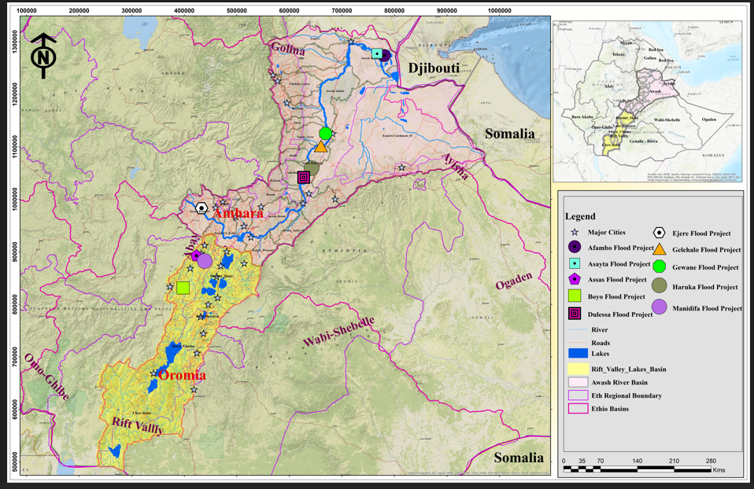
Figure 1. Location Map of Rift Valley Flood Protection Projects.
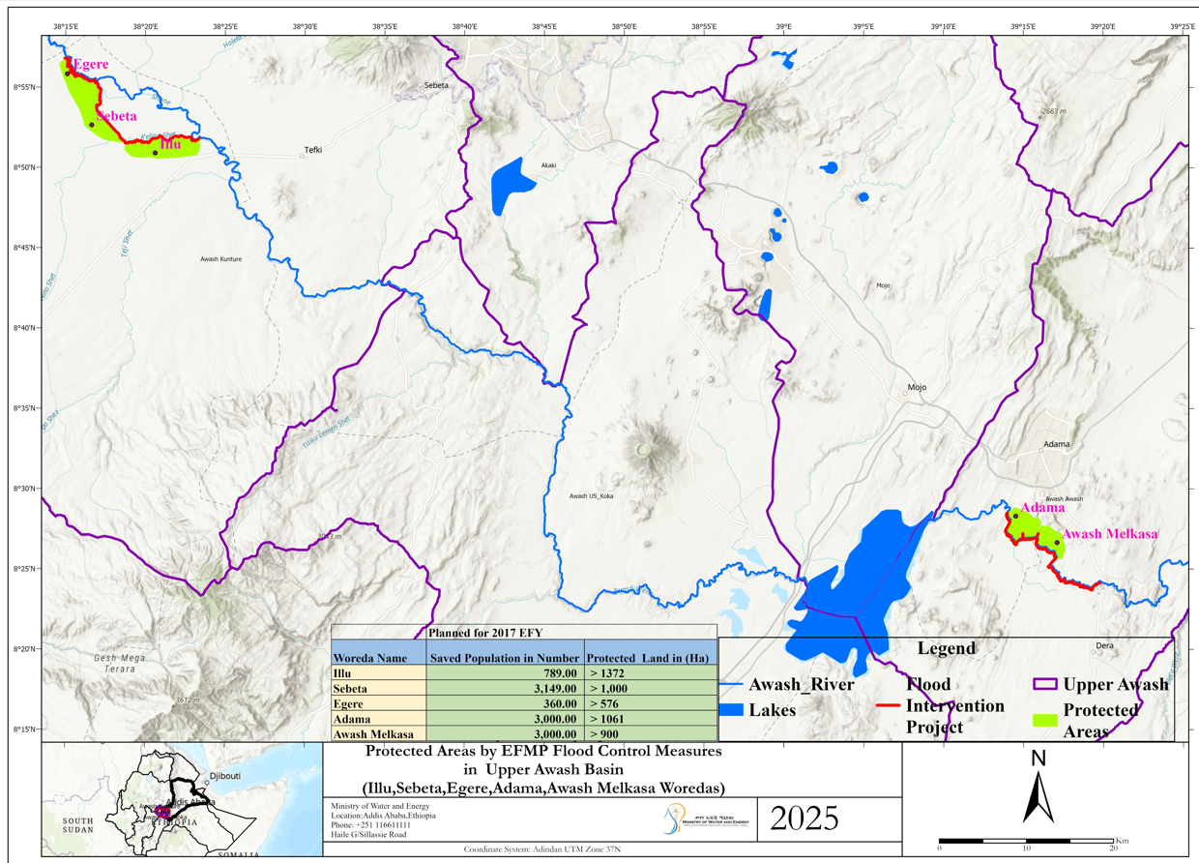
Figure 1. Location Map of Upper Awash Flood Protection Projects.

- Objectives of the Assignment
The overall objective of this assignment is to provide comprehensive construction supervision and contract administration services for the structural works to be implemented under the Ethiopian Flood Management Project in the Awash Basin, including pedestrian bridges, water intake structures, cattle troughs, and associated civil works.
The supervision services aim to ensure that all construction activities are carried out in full compliance with the approved designs, technical specifications, Bills of Quantities, Environmental and Social Management instruments, and World Bank procurement and contract management requirements, within the agreed time, cost, and quality standards.
Specifically, the objectives of the supervision assignment are to:
- Ensure that the construction works are executed in accordance with the approved engineering designs, drawings, specifications, and applicable Ethiopian and international standards;
- Monitor, control, and document construction quality, progress, quantities, and site safety, and verify that materials, workmanship, and construction methods meet the required standards;
- Measure and quantify executed works, maintain accurate site records, and review, certify, and recommend contractors’ interim and final payment requests in accordance with the contract provisions;
- Prepare and submit regular progress reports (monthly, quarterly, and as required) to the Ethiopian Flood Management Project (EFMP), covering physical progress, financial status, quality control, environmental and social compliance, key issues, and risk mitigation measures;
- Ensure full compliance with environmental, social, occupational health and safety (OHS), and community protection requirements, including the implementation of mitigation measures outlined in the ESMP;
- Provide effective contract administration services, including review of contractors’ work programs, method statements, shop drawings, and management of variations, claims, and extensions of time;
- Identify, assess, and resolve technical and implementation challenges in a timely manner, and recommend corrective actions or design adjustments where necessary, in consultation with the Client;
- Coordinate and integrate implementation activities with relevant local administrations, sector offices, and beneficiary communities, to facilitate smooth construction progress, minimize disruptions, and address community concerns;
- Ensure that the completed structures are safe, functional, climate-resilient, and responsive to local needs, thereby maximizing the socio-economic and flood risk reduction benefits of the investments.
The assignment ultimately seeks to support the successful, timely, and sustainable delivery of flood-resilient infrastructure, contributing to improved community mobility, water access, and livelihood protection in the Awash Basin.
- Scope of Services
The Consultant shall provide full-time construction supervision and contract administration services for the structural works to be implemented under the Ethiopian Flood Management Project in the Awash Basin. The scope of services shall cover the entire construction period, including defects liability, and shall include—but not be limited to—the following tasks:
The structures to be constructed under the project include the following:

Table 1. Structure in Asase River Flood protection projects
No. | Description | Unit | Qty
1 | PIPE CULVERT STRUCTURES Dia 1200mm | No. | 4
2 | PIPE CULVERT STRUCTURES Dia 900mm total | No. | 3
3 | PEDESTRIAN BRIDGE | No. | 2

Table 2. Sttructur for Upper Awash Flood Protection Projects
No. | Description | Location | Unit | Qty
1 | PEDESTRIAN BRIDGE | Illu | No. | 1
2 | PEDESTRIAN BRIDGE | Sebeta Hawase |  | 1
3 | PEDESTRIAN BRIDGE | Ejere |  | 4

Table 3 .Pedestrian bridge Structure Boyo2 Guder Meranchi Flood Protection Project
Item No. | Description (River Name) | No of Structure
Item No. | Description (River Name) | (in PCS)
1 | Old Guder River | 4.00
2 | Meranchi Boyo Lake Outlet Channel | 1.00
3 | Meranchi Boyo Lake Inlet Channel | 1.00
 | SUB TOTAL | 6.00

Table 4 . Pedestrian bridge Structure Boyo2 Guder Welenchi Flood Protection Project
Item No. | Description | No of Structure
Item No. | Description | (in PCS)
1 | Mechentoses River | 4.00
2 | Kefo River | 2.00
3 | Machebi River | 1.00
4 | Welechi River | 2.00
 | SUB TOTAL | 9.00
Table 5 . Electromechanical Equipment’s.
Item No. | Description | No of Structure
Item No. | Description | (in PCS)
1 | Solar Panel with Submersible Pump | 4.00
 | SUB TOTAL | 9.00
Note: The above projects will be revised based on the final designs submitted by the design consultant, and the locations and capacities of the solar panels, along with the pumps and their locations, will be determined following the completion of the final design.
5.1 Pre-Construction Phase
- Review and familiarize with all relevant project documents, including detailed engineering designs, drawings, technical specifications, Bills of Quantities (BoQs), Environmental and Social Management Plans (ESMPs), and contract documents;
- Assist the Client during the mobilization and commencement phase, including participation in site handover and pre-construction meetings;
- Review and approve the Contractor’s:
  - Work program and construction schedule,
  - Method statements,
  - Site layout plans,
  - Quality assurance and quality control (QA/QC) plans,
  - Environmental, social, and occupational health and safety (OHS) implementation plans;
- Verify availability and suitability of construction materials, equipment, personnel, and laboratories prior to commencement of works.

5.2 Construction Supervision and Quality Control
- Provide continuous on-site supervision to ensure that construction works for pedestrian bridges, water intake structures, cattle troughs, and associated civil works are executed in accordance with:
  - Approved designs and drawings,
  - Technical specifications and BoQs,
  - Applicable Ethiopian standards and relevant international best practices;
- Monitor construction progress against the approved schedule and identify potential delays, bottlenecks, and risks;
- Ensure proper setting-out, alignment, levels, dimensions, and structural integrity of all works;
- Supervise material testing, workmanship, and construction methods to ensure compliance with quality standards;
- Ensure that construction activities are implemented in a climate-resilient and technically sound manner, suitable for flood-prone environments.

5.3 Measurement of Works and Payment Certification
- Measure, verify, and quantify executed works on a regular basis in accordance with the BoQs and contract provisions;
- Maintain accurate site records, including daily logs, measurement books, test results, and photographic documentation;
- Review, certify, and recommend:
  - Interim Payment Certificates (IPCs),
  - Final payment certificates,
ensuring that payments correspond to actual completed and approved works;
- Verify variations and provisional sums and provide technical justification and recommendations to the Client.

5.4 Contract Administration and Technical Support
- Administer the construction contract in accordance with the applicable World Bank Standard Procurement Documents and Conditions of Contract;
- Review and approve shop drawings, as-built drawings, and construction details submitted by the Contractor;
- Assess and make recommendations on:
  - Variations,
  - Claims,
  - Extensions of time,
  - Price adjustments, where applicable;
- Identify design or site-related issues encountered during construction and propose practical technical solutions in consultation with the Client;
- Ensure timely completion of works within the approved budget and contractual timeframe.

5.5 Training and Capacity Building for Operation and Maintenance
- Plan and conduct practical, community-level training on the operation and maintenance (O&M) of solar-powered pumping irrigation systems installed under the Project;
- Develop simple and user-friendly training materials (manuals, checklists, and visual aids) in a language understandable to the local community;
- Train selected community members, water user groups, and relevant local stakeholders on:
- Basic system components and functions of solar pumping systems,
a. Routine operation procedures and safety practices,
b. Preventive maintenance and troubleshooting,
c. Efficient water use and system protection during flood and dry seasons;
- Demonstrate hands-on operation of the systems at site level to ensure practical understanding and sustainability;
- Support the establishment or strengthening of community-based O&M arrangements to ensure long-term functionality of the irrigation systems;
- Document training activities, attendance, and outcomes, and submit training completion reports to the Client

5.6. Environmental, Social, and OHS Compliance
- Supervise and monitor implementation of all environmental, social, and occupational health and safety (OHS) measures as outlined in the ESMP and contract documents;
- Ensure protection of workers, communities, livestock, and existing infrastructure during construction;
- Monitor community health and safety risks, including safe access, pedestrian movement, and livestock crossings;
- Report and follow up on any incidents, non-compliance issues, or grievances, and ensure corrective actions are implemented promptly.

5.7. Coordination and Stakeholder Engagement
- Coordinate construction activities with:
  - Local administrations,
  - Relevant sector offices,
  - Basin Development Offices,
  - Beneficiary communities;
- Facilitate effective communication between the Contractor, the Client, and local stakeholders to minimize disruptions and address community concerns;
- Support conflict resolution related to access, land use, water use, and construction impacts during implementation.

5.8. Reporting and Documentation
- Prepare and submit regular progress reports to the Ethiopian Flood Management Project (EFMP), including:
  - Weekly Report
  - Bi weekly Executed activity takeoff sheet together with surveying Dta
  - Monthly progress reports,
  - Quarterly summary reports,
  - Special reports as required;
- Reports shall cover physical progress, financial status, quality assurance, environmental and social compliance, key challenges, and recommended actions;
- Prepare completion reports, including as-built documentation and final technical summaries at the end of the assignment.

5.9. Defects Liability Period and Completion
- Supervise works during the Defects Liability Period, including inspection of reported defects and verification of corrective actions;
- Verify completion of outstanding works and certify issuance of completion and defects liability certificates;
- Support the Client during final handover of the completed structures.
- Staffing Requirements
Table 6.1: Key Staff Qualification, Experience, and Input
No. | Position | No. of Staff | Minimum Qualification | Relevant Experience | Input / Duration (Months)
1 | Resident Engineer (Team Leader & Contract Specialist) | 1 | MSc/BSC in Civil / Hydraulic / Water Resources Engineering,or related field | Minimum 10/12 years of professional experience in flood protection, river engineering, or related infrastructure projects, including at least 4 years in construction supervision and strong experience with World Bank Projects | 10
2 | Site Engineer | 2 | MSc/BSc in Civil Engineering/Hydraulic Engineering ,or related field | Minimum 6/8 years of experience in supervision of civil works including bridges, intake structures and hydraulic structures, and flood | 10
3 | Geotechnical & Materials Engineer | 1 | MSc/Bsc in Geotechnical Engineering / Engineering Geology or, related field | Minimum 6/8 years of experience in soil investigations, foundation design review, embankments, material testing, and QA/QC for hydraulic and flood-related infrastructure | 9
4 | Quantity Surveyor | 1 | MSc/Bsc in Civil Engineering/Hydraulic Engineering ,or related field | Minimum 6/8 years of professional experience in quantity surveying and cost management of civil works projects, including preparation and review of Bills of Quantities (BoQ), cost estimation, contract administration, measurement and valuation of works, and related
5 | Structural Engineer | 1 | MSc/Bsc in Civil/Structural Engineering ,or related field | Minimum 6/8 years of experience in design review and supervision of reinforced concrete and steel structures, including pedestrian bridges and hydraulic structures | 9
6 | Electro-Mechanical Engineer | 1 | BSc or MSc in Electro-Mechanical / Electrical / Mechanical Engineering | Minimum 6/8 years of experience in installation, testing, commissioning, and supervision of solar-powered pumping systems, electro-mechanical equipment, and irrigation infrastructure | 4
7 | Environmental & Social Specialist | 1 | MSc/Bsc in Environmental Science, Social Science, or related field | Minimum 8/6 years of experience in World Bank environmental and social safeguards, ESMP implementation, OHS, and community engagement | 9
8 | Surveyor & CAD Technician | 2 | BSc/Diploma in Surveying or related field | Minimum 6/8 years of experience in topographic surveys, setting-out of civil works, quantity verification, and preparation of as-built drawings | 10

Note:- The supervision arrangement shall comprise two field teams, each consisting of a Site Engineer and a Surveyor. These teams shall be supported by key professional staff, including a Resident Engineer, Geotechnical Engineer, Quantity Surveyor, Structural Engineer, Electro-Mechanical Engineer, and Environmental and Social Specialist and the consultant deploy its staff in full time based.
All assigned key personnel are full-time staff dedicated to the project in accordance with the man-month inputs specified in the ToR

Table 6.2. Vehicles, Field Testing Equipment, and Field Office Facilities Provided by the Consultant
No. | Description | Purpose | Quantity | Duration  (Month) | Remarks
1 | 4WD Vehicle | For site supervision, coordination, and field mobility in flood-prone areas | 1 | 10 | Fully equipped with fuel, driver, insurance, and maintenance
2 | 4WD Vehicles | For parallel site supervision and technical staff mobility | 2 | 9 | Same conditions as above
3 | Total Station | Surveying, setting-out, level control, quantity verification, and as-built surveys | 1 | 9 | Complete with accessories
4 | Dynamic Cone Penetrometer (DCP) &  Concrete Slump Test Apparatus (Abrams Cone) | Field tests and basic QA/QC support for construction supervision | 1 | 9 | Supporting Site and Geotechnical Engineers through field soil strength testing (DCP) and concrete workability testing (slump test) during supervision
5 | Field Office Rent | Provision of fully equipped field office for the supervision team, including office furniture, , and space for reporting and coordination activities. | 2 | 9 | For coordination activities
Note: The vehicles and other materials required for the project shall be used by the Consultant exclusively for project implementation. The Consultant is required to quote monthly service rental rates for these resources in the financial proposal.
Upon completion of the assignment, all vehicles and materials shall remain the sole property of the Consultant, and no ownership shall be transferred to the Client.

Table 6.3. Reporting and Documentation
No | Description | Unit | Qty | Remarks
1. | Preparation of Monthly Progress report together with 4 Weeks status report and 2 Biweekly report together with all supporting documents | Monthly. | 9 | Includes drafting, compilation, printing, and submission to Client
2. | Completion Report and as built Drawing | No. | 1 | Includes drafting, compilation, printing, and submission to Client

- Deliverables & Payment Terms
Table 7. 1: Report Deliverables and timelines
Deliverable | Submission Timeline
Inception Report | 2 weeks
Weekly Status Report together with weekly executed takeoff sheet | weekly
Monthly Progress Reports | Monthly
Safeguard Compliance Reports | Quarterly
Environmental & Social Compliance Audit | Quarterly
Final Completion Report | Post-construction
As-built Drawings & operation and maintenance manual | Post-construction
Final Payment Certificate | End of project

- PAYMENT TERMS
The Consultant’s remuneration shall be structured based on the delivery of services and submission of required outputs, as follows:
The Consultant’s remuneration shall be structured based on the delivery of services and submission of required outputs, as follows:
Advance Payment.
Upon provision of an unconditional Advance Payment Guarantee, the Client will pay an advance of 10% of the Contract Amount. The advance shall be repaid in installments deducted from each interim payment, with the full amount to be recovered by the time the cumulative financial progress of the Works reaches 80% of the Contract Amount
- Interim Payments:
  - Interim payments shall be made on a monthly basis, subject to the submission and approval of the Consultant’s progress reports, bi-weekly quantity takeoff sheets supported by verified surveying data, and confirmation of satisfactorily executed construction supervision activities and site records.
  - Payments shall cover staff inputs, vehicles, equipment, field office facilities, and routine field testing as mobilized during the reporting period.
- Final Payment:
  - The final payment shall be effected only after:
    - Successful completion of the assignment, including supervision of all construction works, QA/QC verification, and implementation of environmental, social, and OHS requirements;
    - Professional handover of the completed structures to the Client;
    - Submission of all required deliverables, including:
      - Completion reports,
      - As-built drawings,
      - Training and O&M documentation,
      - Final quality control records and other agreed documentation.
      - Review, verify, and certify the Contractor’s Final payment requests and submit them to the Client for final approval, confirming that all contractual, technical, and documentation requirements have been fully met
  - The final payment will reflect any adjustments for variations, provisional sums, or contractual claims approved by the Client.
- General Notes:
  - All payments shall be made in accordance with the contract provisions and applicable World Bank Standard Procurement Documents
- Duration
The consultancy shall continue until the completion of construction works, final inspection, professional handover, and acceptance by the Ministry, including supervision during the Defects Liability Period.
- Total Consultancy Duration: 10 months
  - Construction Works: To be completed in 9 months
  - Construction Supervision: 9 months
  - Reporting, Training, Final Deliverables, and Project Handover: 1 month
Notes:
- The total duration accounts for all supervision, QA/QC, contract administration, field testing, community training, reporting, and submission of as-built documentation.
- The Consultant shall mobilize staff, vehicles, equipment, and field offices in accordance with the assignment schedule.
- Final completion is defined as the issuance of all completion certificates, submission of all deliverables, and formal handover to the Client.

- Ethics, Quantity Measurement, Quality Control, and Payment Approval Responsibilities
In addition to the tasks listed above, the Consultant shall be responsible for upholding the highest standards of professional ethics and diligence in the execution of their duties, including the following:
- Ethical Conduct:
  - All staff of the Consultant must conduct themselves with integrity, impartiality, and transparency in all project activities, including interactions with the Contractor, Client, local stakeholders, and communities.
  - Any form of conflict of interest, favoritism, or unethical practice during supervision, measurement, or certification shall be strictly prohibited.
- Weekly Measurement, Surveying, and Quantity Verification:
  - The Consultant shall measure and verify quantities of works executed on a weekly basis, using approved surveying methods and instruments.
  - Measured quantities shall be documented in detailed weekly takeoff sheets, accompanied by surveying data, level measurements, and photographic records.
  - These weekly measured quantities, including supporting survey data, shall be submitted to the Client for review and record-keeping.
  - Any discrepancies, over- or under-measurements must be immediately reported to the Client, along with recommendations for corrective actions.
- Quality Control and Issue Reporting:
  - The Consultant shall continuously monitor and verify the quality of materials, workmanship, and construction methods.
  - All identified quality issues, defects, or non-conformance with approved designs, specifications, or safety standards shall be documented, reported to the Client, and communicated to the Contractor for immediate corrective action.
  - A comprehensive quality issue log shall be maintained and included in weekly and monthly reports to ensure traceability and accountability.
- Payment Certification and Approval:
  - The Consultant shall review and approve all payment requests (Interim and Final Payment Certificates) based strictly on verified executed works, measured quantities, and quality compliance in accordance with the contract provisions.
  - Payments shall not be approved for works that are incomplete, substandard, or non-compliant with the approved designs, technical specifications, or safety standards.
  - All payment certifications must comply with the contract provisions and attach necessary supporting documents (takeoff sheets, survey data, OGL, as-built data, CAD drawings if necessary. Any overpayment or redundancy arising from improper approval by the Consultant shall be recoverable and may result in penalties or sanctions.
- Accountability and Compliance:
  - Failure to adhere to ethical standards, proper quantity verification, or quality control and payment procedures may result in sanctions, including formal warnings, withholding of remuneration, suspension, or termination of the consultancy contract, as deemed appropriate by the Client.
  - The Consultant shall maintain comprehensive records of measurements, survey data, quality issues, approvals, and decisions to ensure full transparency and traceability for auditing and oversight purposes.

The Team Leader, together with the Site Engineer and Surveyor, will use this vehicle for an additional one month to support project handover activities
The Team Leader, together with the Site Engineer and Surveyor, will use this vehicle for an additional one month to support project handover activities

